* 2-way ANOVA on averaged rating score
  + Condition: friend vs. stranger
  + Type: grateful, obligated, want

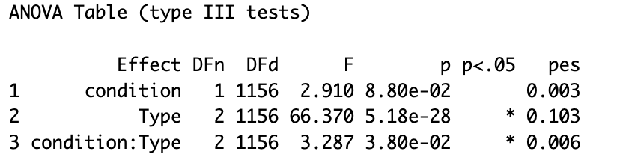

* Test of simple main effects of condition

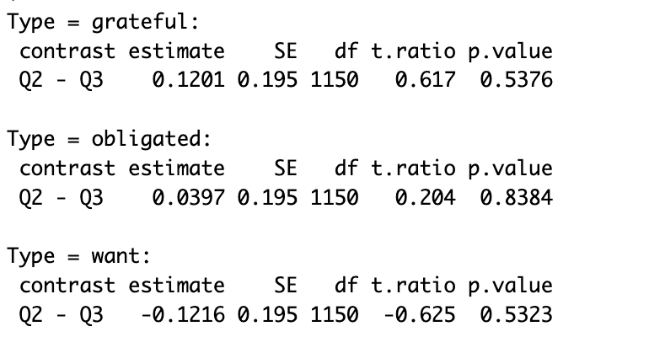

* Test of simple main effects of type

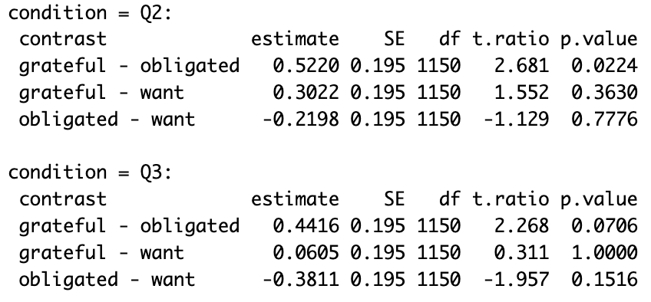

Grateful and obligated are different at both friend and stranger condition

* Pairwise comparison for type
* 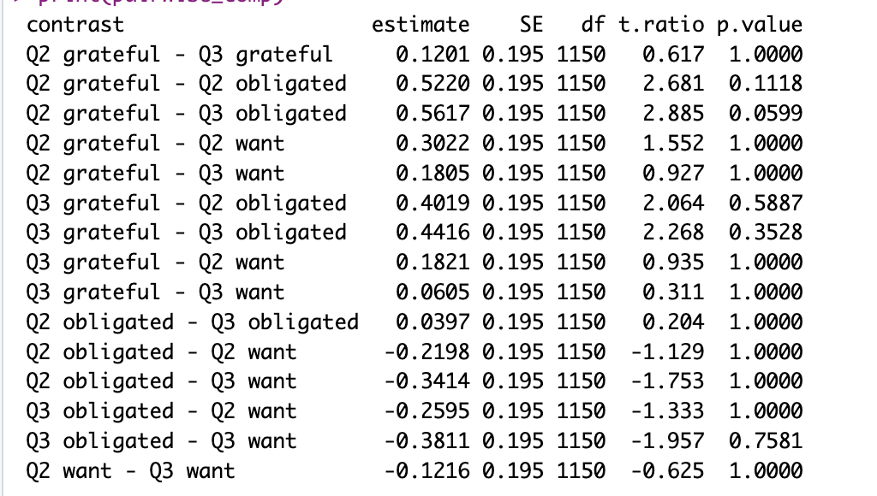

If only looking at Q17-20 (monetary) - same analysis

* ANOVA

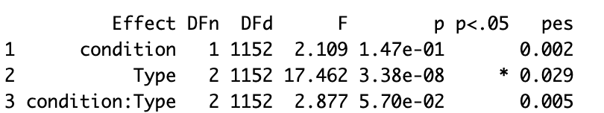

interaction between condition and Type becomes marginal

* Test of main effects:

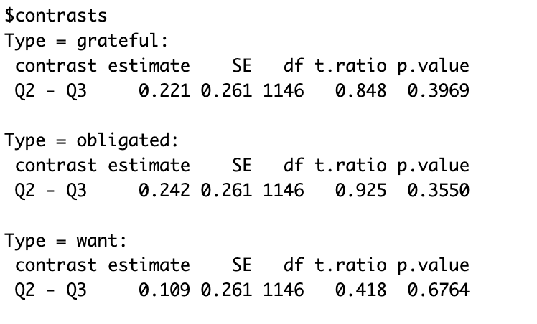

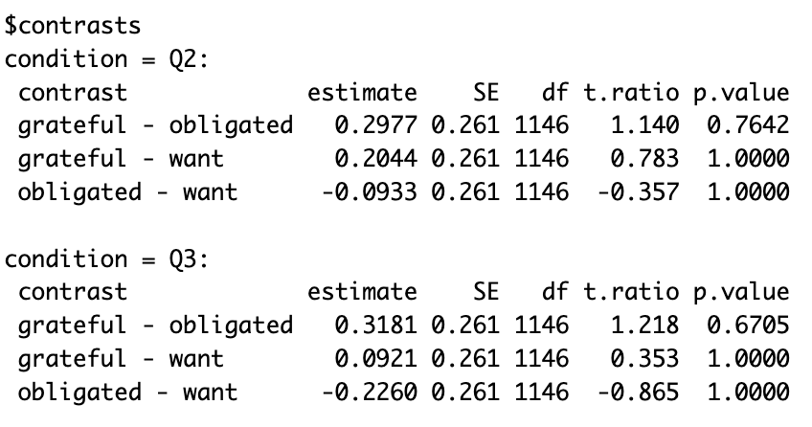

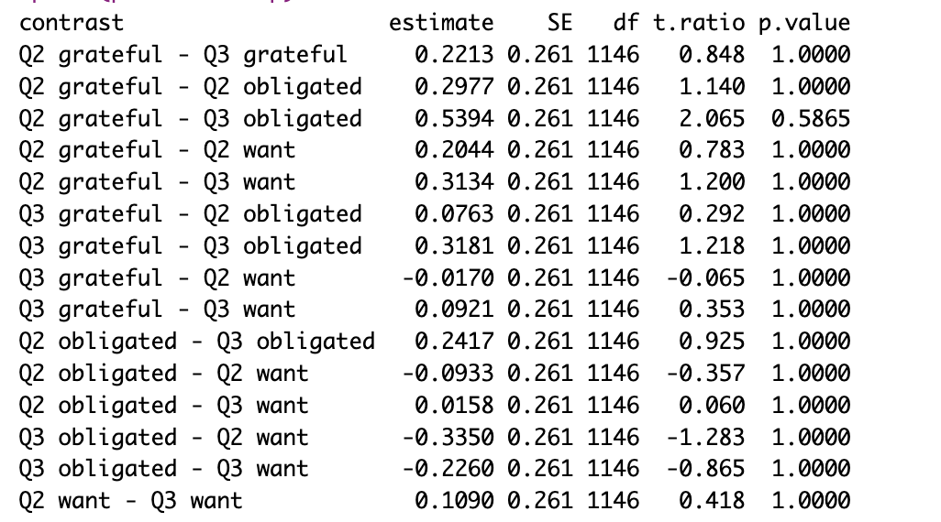

Seems that S17-20 was rather insensitive to the change of wording in our questions